Work report 24 july 2021

Today I have trained the yolo v4 model till 5980 epochs.

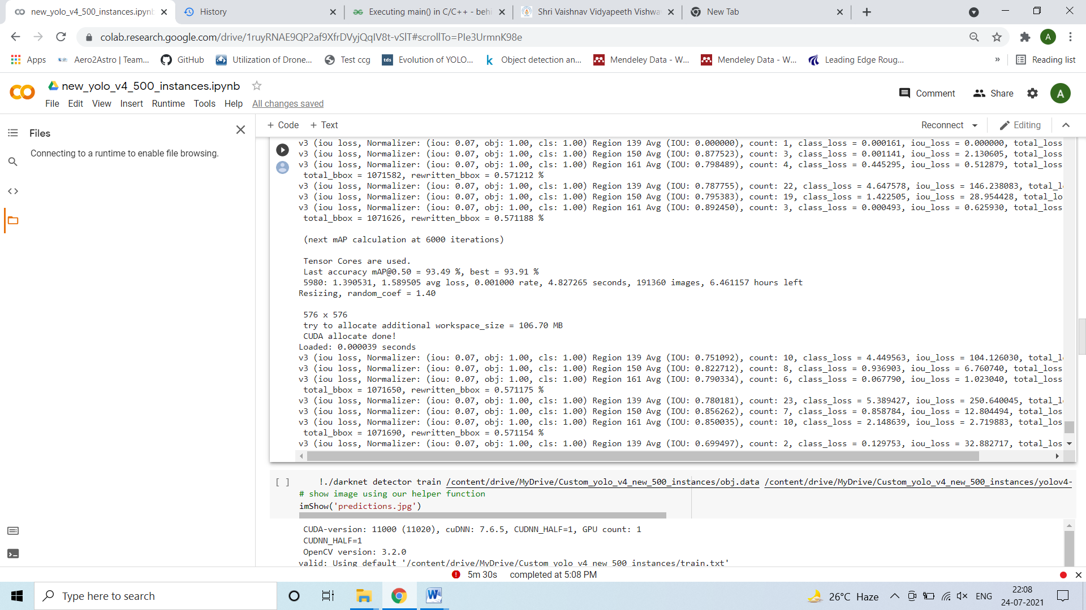

The performance of the model after 3900 eopchs is as follows:

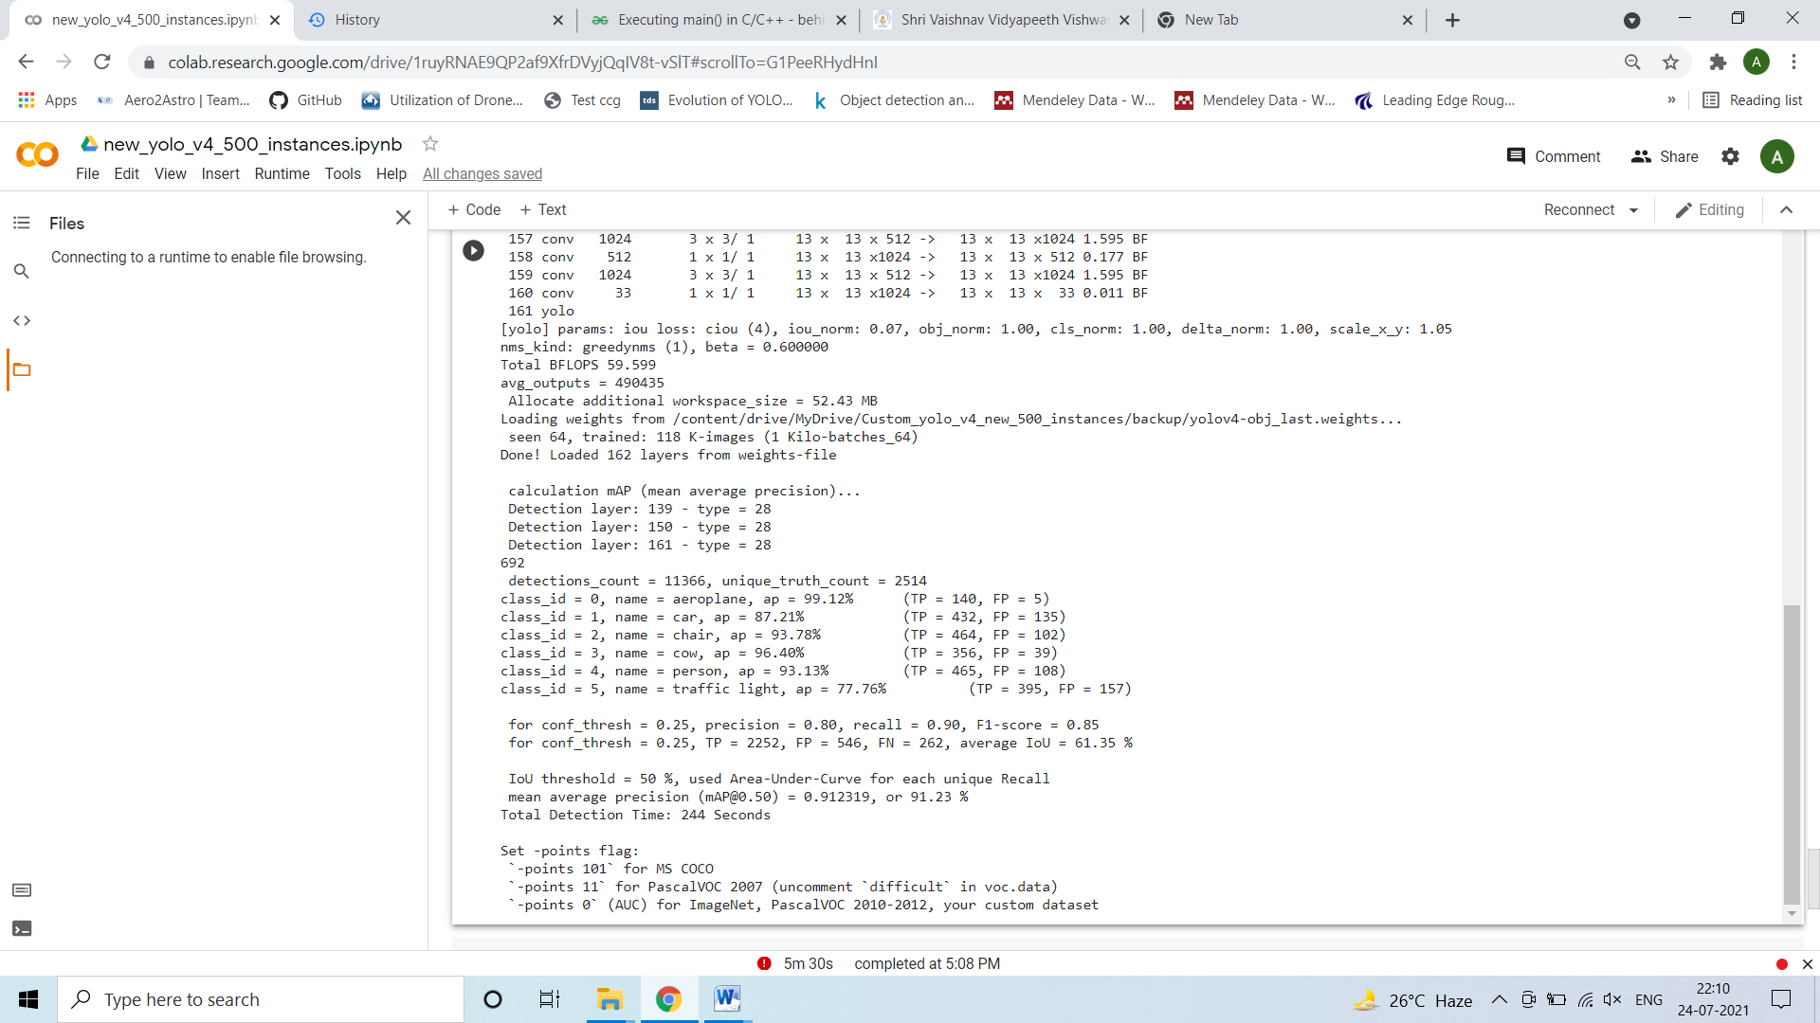

I was also trying to convert the darknet weights to tflite weights. I have read that we need to convert this weights to .pb file first then tflite format.

I was facing issues regarding this conversion I will try it tomorrow.